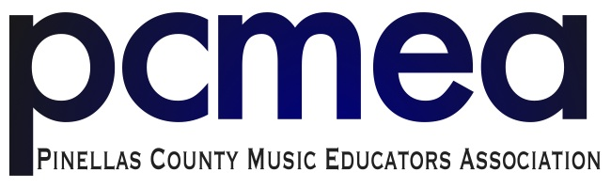

2018 All-County MS Jazz Audition Information

The All-County Jazz auditions will take place on Wednesday, March 7th at Northeast High School
Students will need to have completed the 2018 PCMEA All-County Contract in order to participate. Those contracts can be turned in the night of the auditions.

For your reference, the All-County rehearsal schedule is as follows:

Thursday, April 12 at Northeast HS 5:00 - 8:30pm.
Friday, April 13 at Northeast HS 5:00 – 9:00 p.m.
Saturday, April 14: Palladium Theatre (details are still being worked out)
253 5th Ave N, St. Petersburg, FL 33701

***NOTE: This is the same weekend as the USF Symphonic Celebration.***

All prepared excerpts are from the Easy Jazz Conception books by Jim Snidero
Improvisation accompaniment is from Jamey Aebersold, Vol. 2, “Nothin’ but Blues” book

NOTE: All diatonic scales should follow All-State pattern. Chromatic scale should be straight 8ths, tonguing ascending, slurred decending.

All Instruments (except Drums)

- Shufflin in F , msr. 37- end (Quarter note = 150)
- Improvisation - Jamey Aebersold, Vol. 2, “Nothin but Blues” book,
Track 5, Fast Blues in Bb, 1 time through the head and 2 full improved choruses
- Bb, Eb, Ab, F Diatonic scales (2 octaves when possible)
- Chromatic Scale, 2 octaves from C (Saxophones)
- Chromatic Scale, 2 octaves from G (Trumpets)
- Chromatic Scale, 2 octaves from F (Trombones)

Drums
- Shufflin in F, msr. 37 – end (Quarter note = 114)
- Demonstrate the following styles:
- Rock (16 bars) in Common Time (Quarter Note = 76)
- Bossa Nova (16 bars in Common Time (Quarter Note = 120)
- Shuffle (16 bars) in Common Time (Quarter Note = 120)

