Viola – All County High School Orchestra
Audition Requirements 2017-2018

- Audition Date: Wednesday, November 15, 2017, Pinellas Park High School
- Viola Scales: C, G, D, A, F, Bb, Eb (with arpeggios) 2 octaves
All Instruments: Extra octaves may earn you extra points

- Audition Excerpt

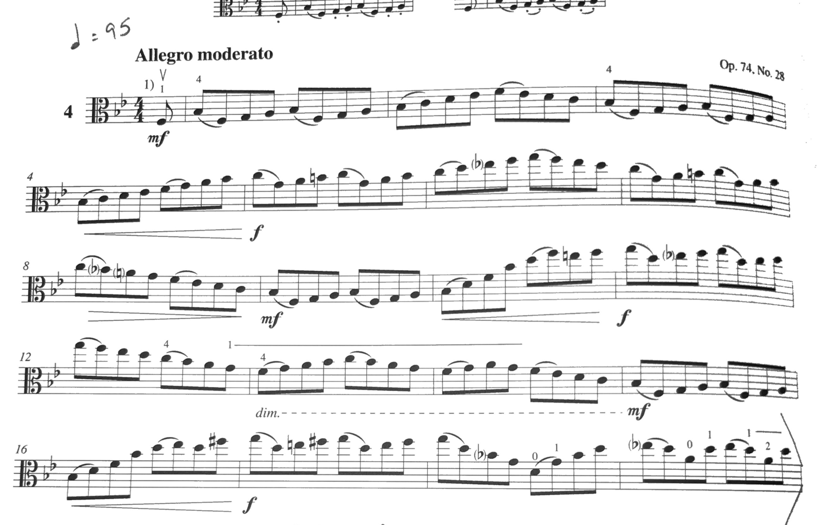

Rehearsal Dates and Times:
January 25th 5:30PM-8:00PM
January 26th 5:30PM-8:00PM
January 27th 9:00AM-3:00PM
Location: To Be Announced
Concert and Dress Rehearsal Date and Times:
January 30th, Dress Rehearsal: Times to be announced
January 30th, Concert at 7:00PM
Mahaffey Theater, St Petersburg, FL

