Violin – All County Middle School Orchestra
Audition Requirements 2017-2018

- Audition Date: Wednesday, November 15, 2017, Pinellas Park High School
- Violin Scales: F, C, D – 1 octave; G, A 2 octaves
- All Instruments: Extra octaves may earn you extra points

- Audition Excerpt

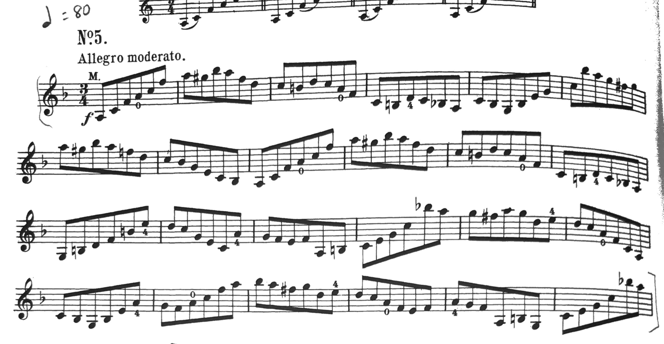

Rehearsal Dates and Times:
January 25th 5:30PM-8:00PM
January 26th 5:30PM-8:00PM
January 27th 9:00AM-3:00PM
Location: John Hopkins Middle School
Concert and Dress Rehearsal Date and Times:
January 30th, Dress Rehearsal: Times to be announced
January 30th, Concert at 7:00PM
Mahaffey Theater, St Petersburg, FL

