***2018-2019 Officers:***

***Pamela Richardson***

President

***Jason Obara***

Past President

***Matthew Clear***

Secretary/Publicity

***Michelle Thomas***

Treasurer

Accounts Receivable

***Jacob W. Merrett***

Treasurer

Accounts Payable

***Janae Robinson***

***Kristin Hecht***

Elementary

***Christopher Ellis***

Middle School Band

***Mary Wyant***

Middle School Choral

***Gerard Madrinan***

High School Band

***Lauren Brautigam***

High School Choral

***Steve Visnage***

Strings

***Jeanne Reynolds***

Supervisor

Pinellas County

PreK-12 Performing Arts

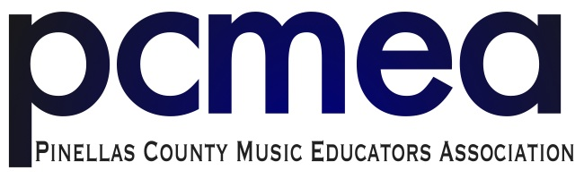

September 19, 2018

Dear Private School Music Colleague,

Pinellas All County Music Events are produced by Pinellas County Schools in partnership with the Pinellas County Music Educators Association (PCMEA). If you are planning to participate in our 2018-2019 All-County Events, please be reminded of the following policies that have been put into place over the recent years.

1. Directors must join PCMEA as an Honorary Member and pay a $15 membership fee.
2. Each student must pay a $15 audition fee. Note that this fee does not ensure placement into an all county ensemble.
3. Elementary students are selected by director nomination. The $15 student audition fee *will* cover elementary participation.
4. Students auditioning for a secondary All-County ensemble must be part of a band, chorus, or orchestra at the school they attend consistent with the ensemble for which they are auditioning.

The application for Honorary membership is found on our website, (<http://www.pcmea-fl.org>) under the All-County tab. Send the completed form and your fees for membership and student registrations to Michelle Thomas at Fuiguitt Elementary (13010 101st St SE, Largo, FL 33773). Vital information regarding auditions, rehearsals, and performances will also be available on the website as the coordinators keep it updated.

Please feel free to contact me with any questions via e-mail at richardsonp@pcsb.org. We are looking forward to another rewarding All County Music Festival!

Sincerely,

Pamela Richardson

President